# Pricing and Costs

### Mortality Savings from Proposed Programs

Across the three proposed offerings, LCG has determined that there would have been immense savings from reduced mortality costs had the program been implemented for the past 20 years, as seen in Figure 4. Appendix B1 outlines the process for determining mortality savings.A blue and white rectangular sign with white text

*Figure 4: SuperLife’s Mortality Savings If The Program Had Been Implemented 20 Years Ago*

*T20 Smoker Bundle*:Our T20 Smoker Package would have provided over Č15m, or 18.48%, in mortality savings, as seen in Figure 4. These large savings are due to the immense mortality improvements seen in younger individuals who successfully quit smoking. Indeed, we see that the mortality improvements through ages are variable (see Appendix B3). It is important to note that the variability in savings at issue ages are a result of many factors such as the variability in actual mortality experience when compared to expected mortality experience or modelling errors. It is important to consider this limitation within the context of the pricing section.

*T20 Non-Smoker Bundle:* Our T20 Non-Smoker Package would have provided over Č88m, or 17.01%, in mortality savings (see Figure 4). The mortality savings are evenly distributed over all age groups with slight variabilities at older age groups due to deviations from expected mortality improvements (see Appendix B4)*.*

*SPWL Non-Smoker Bundle*:For the Whole Life Non-Smoker Package, we estimate total mortality savings of over Č22m, or 12.12%, as depicted in Figure 4. Similar to the T20 Non-Smoker Package, the mortality savings are fairly evenly distributed over all age groups with slight deviations due to the variability of actual mortality experience in relation to the expected mortality experience (see Appendix B5).

### Economic Value Added From Proposed Program

When determining the added economic value of our proposed programs, our team projected sample portfolios of new sales in the year 2025 that follows the same composition of policies at each issue age as the overall book over the past 20 years (see Appendix B2). Added economic value from our bundles is calculated by the difference between the net present value of the portfolio with our proposed program and the net present value of the portfolio without the program. This portfolio of new sales is projected over suitable time frames such as 20 years for 20-year term policies and 20, 40 and 60 years for whole life policies.

*Figure 5: SuperLife’s Economic Value Added Over Appropriate Timelines*

*T20 Non-Smoker Bundle:*Over a 20-year timeline, our T20 bundle with the preventative screening program has an added economic value of 7.62%, equivalent to over Č14,000 for every 100 policy bundles sold. Each issue age of our portfolio provides added economic value with the largest increases occurring at younger ages due to a smaller premium reduction at ages under 30. However, after ages 30, the added economic value increases from 4% at issue age 31 to 7.3% at issue age 45, demonstrating the improved profitability for older ages (see Appendix B6).

*T20 Smoker Bundle:* Over a 20-year time horizon, our T20 bundle with the smoking cessation program has an added economic value of 13.38%, equivalent to over Č80,000 for every 100 policy bundles sold. The largest increases in economic value occur at older ages of each premium reduction segment. For example, for the premium reduction of 2% between ages 25-30, the largest added economic value occurs at age 30. This is the same for ages 31-35 and ages 36-40, in line with our expectations (see Appendix B7).

*SPWL Non-Smoker Bundle:*For our whole life policy bundle, we projected our sample portfolio over 3 different time frames, that is, 20-year, 40-year and 60-year. Over a 20-year period, our initial portfolio has a 0.40% added economic value, with ages less than 55 having lost economic value, due to the cost benefits of mortality reductions not yet exceeding the intervention expenses and cash-backs, and ages greater than 55 having small added economic value. However, after a 40-year projection, we see an added economic value of 5.92%, with all age issue segments being profitable. Over the 60-year projection, our model suggests that the program provides 5.08% of added economic value. Over both 40 and 60-years, our projections indicate that issue ages 50-65 will be the most profitable (see Appendix B8).

### Pricing Strategy: Proposed Pricing Changes

Given the characteristics of our policyholders relative to the wider Lumarian population, as well as, our own projections for Lumaria’s population, as seen in Appendix C2, we have introduced a range of pricing changes that aim to create the most economic value for Lumaria, whilst still maintaining ethical decision making. Indeed, the premium discounts we provide to those that engage with the smoking cessation program depend on the age of the policyholder as covered in program design, with those under the age of 30 receiving a 2% discount, those under the age of 35 a 5% discount, and those under the age of 40 an 8% discount. Similarly, the premium discounts we provide to those that engage with the preventative screening program depend on the age of the policyholder, with those under the age of 30 receiving a 3% discount and those under the age of 45 receiving a 5% premium discount. Individuals engaging with the heart screening program are provided with a 1.5% premium discount to their lump sum whole life premium paid at the beginning of the policy.

Our pricing model projecting these pricing changes over suitable timeframes indicates increases in profitability despite reductions in premium and cash-back schemes. Thus, the proposed pricing changes optimize sales through added financial incentives and improve the profitability of policies on a per policy and aggregate basis. Furthermore, premium reductions to incentivize healthy behaviours and ultimately lower mortality whilst adding economic value reflects LCG and SuperLife’s focus to consider ethical objectives beyond just profit maximization.

Pricing Appendix

### Appendix B: Pricing and Costs

*Appendix B1: Mortality Savings Macro Code*

Explanation: By utilising the in-force data, we simulated through all the mortality experiences at each issue age over the past 20 years, starting from 2004. This required us to find the different possible mortality years experienced over each different policy type. For example, for an individual aged 35, who was issued a T20 policy in year 2014, they would have only experienced at most 10 years of their policy, thus we simulate the expected mortality cost of 10 years. We do this for each age issue for each of our policy bundles, in accordance with our Figure 1. The final expected mortality costs at each age issue is then returned utilising the macro below. This is then subtracted from the actual mortality costs at each age issue for the given policy type as found in the in-force dataset to obtain the mortality savings.

*Appendix B2: Deriving Economic Value*

Our process to derive the economic value of our process is as follows. To start off, we have to determine what the premium is for the policy to obtain a net present value of 0. This is done using the solver function in Excel. After this, we apply a 20% premium loading to obtain our estimated premium if we were not implementing our program. We also obtain the net present value as a proxy for profits obtained under this policy type. We then implement the mortality improvements and intervention costs into our Excel model to create a new model that includes the benefits and costs of our intervention program. We apply the premiums obtained from the previous policy types, however also applying the premium discounts we offer as financial incentives. We then loop through each issue age, as each issue age has different premium discounts as well as different mortality improvement, to obtain the net present value at each issue age. The difference between the net present value we just calculated with the intervention program and the net present value without the intervention program is used as a measure for the added economic value. We utilise the composition of the original book to perform a weighted sum on the economic value at each issue age to obtain an average economic value for each policy sold. This is multiplied by 100 for our final metric of added economic value per 100 policies sold.

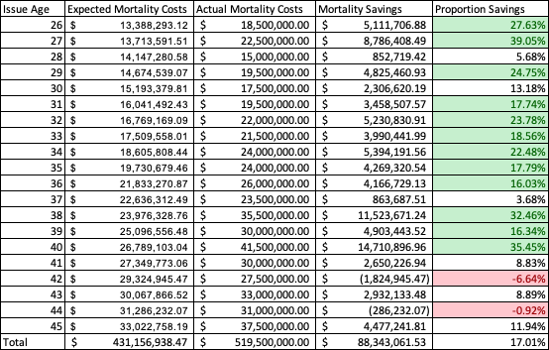*Appendix B3: Mortality Savings T20 Non-Smoker Bundle*

*Appendix B4: Mortality Savings T20 Smoker Bundle*

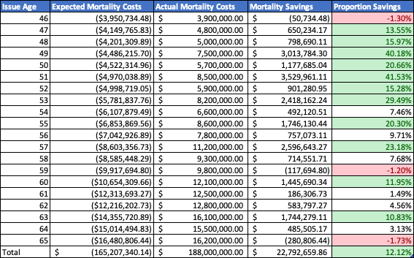*Appendix B5: Mortality Savings SPWL Non-Smoker Bundle*

*Appendix B6: T20 Non-Smoker - Granular Results Over 20 Years*   
As referenced in the main body of the report, our T20 Non-Smoker Bundle is most profitable at younger age groups, due to the smaller premium reduction. However, at older ages larger premium reductions reduce the overall profitability. The mortality improvements at older ages are significantly higher, resulting in the increase in added economic value from 3.97% at age 30 to 7.29% at age 45.

*Appendix B7: T20 Smoker - Granular Results Over 20 Years*

Over a 20 year projection, the T20 Smoker Bundle is profitable at all ages, increasing at each age segment of premium reduction. That is, between ages 26-30, 31-35 and 36-40 all have the largest percentage profitability or largest percent added economic value at the older ages of the segment. Furthermore, unlike T20 Non-Smoker, the profitability increases at each age. For example, whereas T20 Non-Smoker bundle was less profitable at age 45, our Smoker bundle is most profitable at age 40.

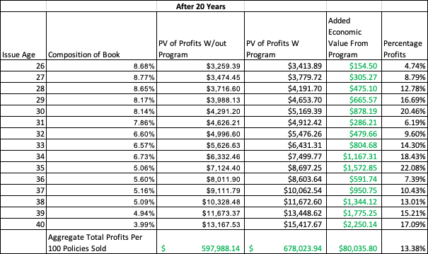

*Appendix B8: Whole Life Non Smoker - Granular Results Over 20, 40 and 60 Years*



